**Drone Navigation Using Brain Computer Interface (BCI)**

Final Year Project Proposal

by

**Muhammad Raheal Safdar**

**Madiha Ansari**

**Naneeta Talreja**

**___________________________________**

**Supervisor:**

Dr. Ahsanullah Abro

____________________________________

**Co-Supervisor:**

Dr. Ahmed Ali Shah

Sir Riaz Afridi

Sukkur IBA University  
Computer Science Department

(2022)

**Abstract**:

The Brain Computer Interfaces (BCIs) are extensively researched as an emerging area of the studies in the field of Human Computer Interaction (HCI). It is understood that the different optimal location for BCI is at the intersection of the humans and machine adaptability. An electroencephalogram (EEG) headset could be put on the user's scalp, where, the non-invasive BCI decodes brain signals to detect and translate the user's neural actions and activities. It is observed that drones are now widely employed for a variety of reasons, including military services, weight lifting, cinematography, photography, and cargo delivery. The several breakthroughs and contributions have also been presented in the BCI-based drone control system in various domains according to their usefulness and applications. However, there is a lack of navigational cues to detect user’s brain signals and to translate them into expected actions and activities accurately. It leads to an inappropriate control of drones for different applications. Thus, it is aimed to design and develop a BCI that could be attributed with a set of navigational cues to control drones in three-dimensional (3D) physical space. Users may be able to control a flying robot (also termed as a drone or UAV) in six directions using non-invasive scalp EEG on human subjects. Those six directions include up, down, left, right, forward, and backward. The EEG is a method that helps in detecting and recording an electrogram of electrical activity on the scalp, which has been shown to represent the macroscopic activity of the brain's surface layer underneath. The proposed BCI may contribute in making life easier for normal as well as people with special needs such as stroke patients (paralyzed) or having difficulty with the motor images. People may control a drone with their minds alone, and also may require no physical action.

**Contents**

**1.0 Introduction:** 4

**2.0 Literature Review:** 5

**3.0 Problem Statement:** 6

**4.0 Project Goals:** 7

**5.0 Proposed Solution:** 7

**6.0 Dataset Discussion:** 7

**7.0 System Architecture:** 7

**7.0 Project hardware and software tools:** 8

**8.0 Modules and their deliverables:** 9

**9.0 Project Budget:** 10

**10.0 Methodology:** 10

**11.0 Project milestones and deliverables:** 11

**12.0 System Development with Agile Methodology:** 12

**13.0 Conclusion:** 13

**References:** 13

# **1.0 Introduction:**

As per the year 2011, World Health Organization (WHO) global report [1] on disability says that one out of every five individuals on the planet Earth is disabled. This worldwide estimate is rising due to the aged people and the rapid spread of deadly disease. Several of these persons have fascicle diseases such as amyotrophic lateral sclerosis (ALS), vertebra damage, ischemic stroke, and other conditions that cause voluntary muscle control to be lost [2]. These people are typically confined to a wheelchair or a bed. They do not have the capability of moving their muscles or cannot move anywhere they want. They have significant obstacles in modern society as a result of their limits and disability to perform basic activities such as playing games with others or conversing with the people. These activities are essential for individual growth and have an important influence on one's life quality. Those who lack motion skills might benefit greatly from devices that increase movement. In recent years, cutting-edge technology such as the BCI has been more widely available to the general public, and our moral obligation is to use such advancements to eliminate such barriers and allow impaired persons to resume a normal life. BCI combines brain and machine integration, with both using the same interface to provide a communication channel between the brain and an externally controlled item. In other words, the brain-computer interface converts users' intents, which affect the encephalographic signal, into control signals for a variety of external electronic equipment [3]. The neural network of the human brain is made up of interconnected clusters of neurons that are responsible for the transfer of information. Hans Berger, a German psychiatrist, was the first to quantify brain waves using electroencephalography, a method for recording brain waves, in 1924 [4]. The EEG equipment, which collects the brain waves produced by neurons and transmits them to a computer, which then converts the signals into data [4], is an example of this technology. This information is transformed into commands for a computer-connected device. Electrodes are used to evaluate brain electrical activity using the EEG headset. Another method is very popular which differentiates other methods with respect of signal acquisition that is SSVEP-based BCI with great potential for usage in virtual reality, allowing the user to control the drone using his or her brain activity in first-person view mode [5], [6].

Delta, Beta, Theta, Alpha, and Gamma are some of the several packs that make up EEG signals. Each pack corresponds to a different sort of mental activity [7]. The strength of these bands is periodically changed during the day. The strength of distinct EEG bands is really related to the brain's activity and state of consciousness [2].

A lot of study has been done in this field in recent years, with researchers seeking to build user-friendly and easy-to-use assistive technology for drone piloting. The purpose of our project is to develop a BCI system that controls the drone's (Tello EDU) movements using human brainwaves.

The following section describes the literature review of previous work on drone navigation with BCI, problem statement, project goals, proposed solution, dataset discussion, system architecture, project hardware and software tools, modules and their deliverables, project budget, methodology, project milestones and their deliverables, system development with agile methodology, conclusion.

# **2.0 Literature Review:**

The focus at work [2] was to control the drone using facial expressions and mental commands to guide it in six different directions (left, right, up, down, forward and backward). The EEG headset used to collect the brain signals was the Emotional Insight (5-channel) and the Parrot Mambo Fly drone was used for the experiment. The accuracy of the tests was 88%, based on the correctness of mental instructions, which indicates how attentive the person is during the test. Signals from the headset are carried to the computer via Bluetooth, and signals from the computer to the raspberry-pi zero microcontroller are sent with the help of Message Queuing Telemetry Transport (MQTT) protocol, which is also used for communication between the drone and the raspberry-pi zero. Emotiv Cortex and the python-3 was used to make the software program. This software allows communication between the computer and the headset.

The EEG headset used to collect brain data was the Emotive EPOC headset (16 channels), and the quadcopter AR 2.0 drone was used for the experiment in the study [8]. The author recovered facial features such as left/right smile, frown and left/right wink. A tablet-based mobile framework based on the Android OS will be created to convert observed patterns into instructions that can be used to control the quadcopter AR 2.0 drone through any wireless medium. The system design includes a signal processing unit, the Emotiv engine development kit and the Emotiv API.

In the study[9], the approach was a fully independent BCI multiclass system based on the Steady-State Visual Evoked Potential (SSVEP) paradigm that is capable of moving the drone in six directions that are up, down, left, right, forward and backward. The EEG headset used to acquire the signals from brain cells was the Emotiv COPD Neuroheadset (16 channels), and the drone was replaced for the experiment by a feedback loop using LEDs that are controlled by an Arduino board. The BCI system was tested on ten healthy controls and gives an accuracy of 92.5% on average. The data obtained from the EEG headset is sent to a desktop using Bluetooth and a USB adapter. A Python script was created and implemented to acquire and decode the EEG raw data signal. MATLAB was used to perform methods like signal processing, feature extraction and classification.

The study [10] methodology specifies four motor imagery tasks that need to be worked on. The first task is to imagine a movement with the left hand without moving the hands. Task 2 is similar to Task 1, but is done with the right hand. Task 3 asks the patient to imagine movements with the left hand, fingers, and elbows. Task 4 is similar to Task 3, but is done with the right hand. For the experiment, an Emotiv Inc. headset was used. EPOC+EEG, which provides 14-lead EEG data, and a Parrot 2 AR drone. For the calculation, a dual dataset is applied to the constructed model. The Python-based algorithm runs on a ground station in continuous duplex communication with the UAV over Wi-Fi.

The inactivity or execution of another movement in which no action is performed is described in the work [11], as well as the blink of the left eye to move in the negative direction of the selected axis, the blink of the right eye to move in the positive direction, the direction of the selected axis, raise your eyebrows to select the axis of movement and idle or perform another movement that does not perform an action. For this experiment, a 16-lead EEG headset was paired with a Parrot Mambo drone. Subjects of both sexes, aged between 18 and 30 years, provided recordings for training classifiers. According to the system, the best performing classifiers are RF (with the data filtered at alpha rate and then scaled between zero and one), which achieves an accuracy of almost 85%, and the CNN network (with filtered data). at the alpha rate), which achieves an accuracy of 86.66%. The program to connect the drone to the BCI modules and classifier is written in Python, using PyQT5 for the interface, pyOpenBCI to connect to the BCI modules and pyparrot for the drone connection and commands.

The aim of the study [12] was to develop an innovative Brain Computer Interface (BCI) system that responds to patients' brain activity and sends a signal to the aircraft telling it to fly in four different directions (up, down, left, right). The Emotiv EPOC helmet (16 wires) was used to collect brain data and a custom quadrotor drone was deployed for the experiment. After just 10 minutes of training, a 52% success rate was achieved by completing a task on time. EEG headset data is transmitted to a laptop via Bluetooth and signals from the laptop to the drone are sent via TCP/IP protocol. A C# software application was created to capture and decode the EEG raw data signal, while two C applications were written. The first software is for the server and resides on the laptop connected Printed Circuit Board (PCB), while the second program is for the client and resides on the drone PCB.

The authors of the article [13] proposed a method in which they trained four different mental tasks, one for each direction of drone control: ascending mental task for takeoff, descending mental task for decreasing altitude, right mental task for the movements of the drone to the right side head and left turn in mental task for left side head movements. The Emotiv Insight headset (7 channels) was used to collect brain signals, while the Parrot Rolling Spider drone was used for the experiment. EEGLAB was used as a programming environment that was used to store, measure, manipulate and to access the EEG data that was gathered through the experiments.

# **3.0 Problem Statement:**

As mentioned before, in recent years, a lot of research has been done in this subject, with researchers attempting to develop user-friendly and easy to use assistive technology for drone navigation. BCI will be the new horizon as an assistive technology being used for drone navigation. However, there is a lack of navigational cues to detect user’s brain signals and to translate them into expected actions and activities accurately to control the navigational cues of drone.

# **4.0 Project Goals:**

The main goal of our project is to design and develop BCI system that will:

1. Establish one-way communication from brain signals to desktop application running on our laptop.
2. Open up the communication between the desktop application and the Drone.
3. Control drone navigation in 3D space.

# **5.0 Proposed Solution:**

We will be having a dedicated system which will have the following specifications:

1. Brain Signal acquisition using EEG headset and transfer them to computer.
2. Preprocessing these signals to extract out such signals that are related to our specified directions.
3. Using those signals to build any Machine Learning model to generate input for drone.
4. Controlling the drone navigation using those generated inputs from our model via any Wi-Fi technology.

# **6.0 Dataset Discussion:**

Thirty healthy subjects (15 male, 15 females, aged 22–30 years, mean 26) are involved voluntarily in data recording phase. In the experimental environment, EEG signals will be captured by EEG headset in real time from user scalp and were processed simultaneously to generate control commands. All participants were instructed to avoid unnecessary movements during experiment. Each subject is asked to think of those six directions that we are implementing in our project and those signals are recorded one by one. Each direction signals are captured for 30 seconds meaning for every direction we have 30 signals for single direction from every subject. Approximately 07-09 minutes are required to acquire signals from one subject. That means the whole process of dataset collection will take 3.5-5.0 hours in total. A written consent will be taken from all volunteers as per good clinical practices (GCP) certification suggestions. This work will have the approval by Computer Science department of Sukkur IBA University.

# **7.0 System Architecture:**

The proposed system will have the following architecture: starting with the headset, OpenBCI, will be used for brain signal acquisition from subject’s mind via scalp from different channel locations as shown in Figure 1 and will be transferred to computer via Bluetooth. The signal will be received by the OpenBCI-GUI that allows you to view your EEG data, interpret your results and creates a window into your brain like never before. We will build a desktop application in C# that will act as intermediator between brain and drone. This application will be accountable for receiving raw signals from OpenBCI software, applying preprocessing on the signals and will use 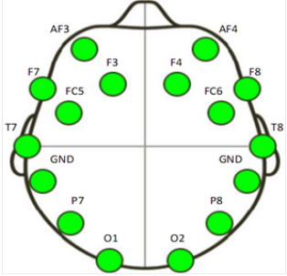ML model for signal classification.

Figure 1 Location of the sixteen channels by OpenBCI

The ML model is the "object" that remains after a machine learning algorithm is applied to training data, and it contains the rules, numbers, and other algorithm-specific data structures that are required to create predictions. The desktop application will generate an output command that will act as an input for the drone and these signals will be transferred to drone via wi-fi. The drone we will be using is Tello EDU. The Drone is programmed in python and can be attached to desktop, laptop or remote controller using the Wi-Fi technology. The proposed system architecture is shown in Figure 2.

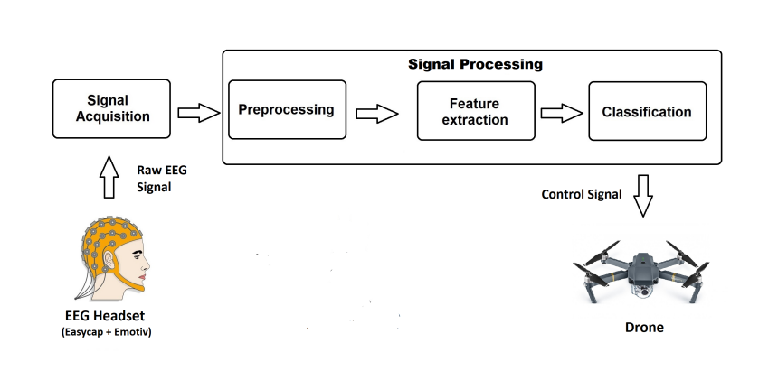

Figure 2 Proposed System Architecture

# **7.0 Project hardware and software tools:**

Following devices will be used in our project, which will be provided by the institution:

1. OpenBCI EEG Headset shown in Figure 3.

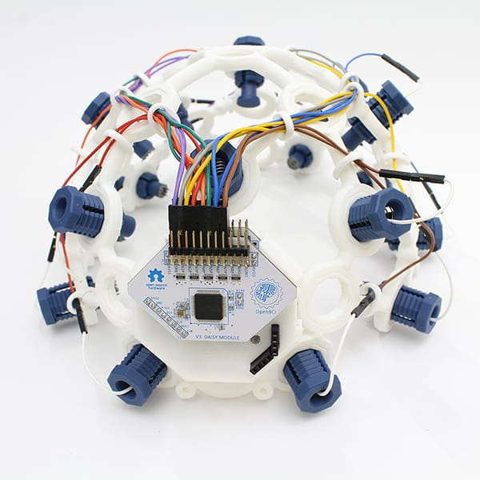

Figure OpenBCI headset

1. Tello EDU Drone shown in Figure 4.

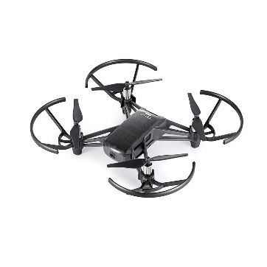

Figure 4 Tello EDU Drone

Following are the tools that we will use in order to make the system:

1. OpenBCI-GUI Software
2. Visual Studio (.NET Framework)
3. Programming Simulator for Drone
4. Python
5. C Sharp

# **8.0 Modules and their deliverables:**

Table 1 tell about the modules and their deliverables.

Table 1 Modules and their deliverables

|  |  |
| --- | --- |
| **Modules** | **Deliverables** |
| Extracting the brain signals through EEG. | Desired signals to generate commands. |
| Desktop Application for preprocessing and ML model training and testing. | Fully working Desktop Application. |
| Commands from Desktop Application to control Drone Navigation. | Drone Navigating in 3D space using brain signals. |

# **9.0 Project Budget:**

Table 2 shows the estimated cost of required hardware and licensed software for the project.

Table 2 Project Budget

|  |  |
| --- | --- |
| **Required Component** | **Estimated Price** |
| OpenBCI headset | Rs. 159000/- Approx. |
| Tello EDU Drone | Rs. 30,000/- Approx. |
| Other maintenance cost | Rs. 10000/- Approx. |
| Total Cost | Rs. 1,99,000/- Approx. |

# **10.0 Methodology:**

There are no strict requirements for the system, we will prefer to employ Agile technique for our system. Agile is a software development process in which the entire project is split down into small pieces and each developer works on their own piece while collaborating with stakeholders and other developers as shown in Figure 5. Clients explain the end product they require, together with the functionalities they require, using this manner. Changes in specifications are readily accepted and applied here, resulting in a speedier delivery of the final product, which can be adjusted further. A planning, executing, and assessing cycle exists. This is continued iteratively, with additional needs added, until a product generation that is more acceptable to the client is discovered at the end.

The four primary values are written as follows:

1. Processes and tools vs. people and their interactions.
2. Working software prioritizes over detailed documentation.
3. Rather than contract discussions, clients should collaborate with you.
4. Planned adaptation to change.

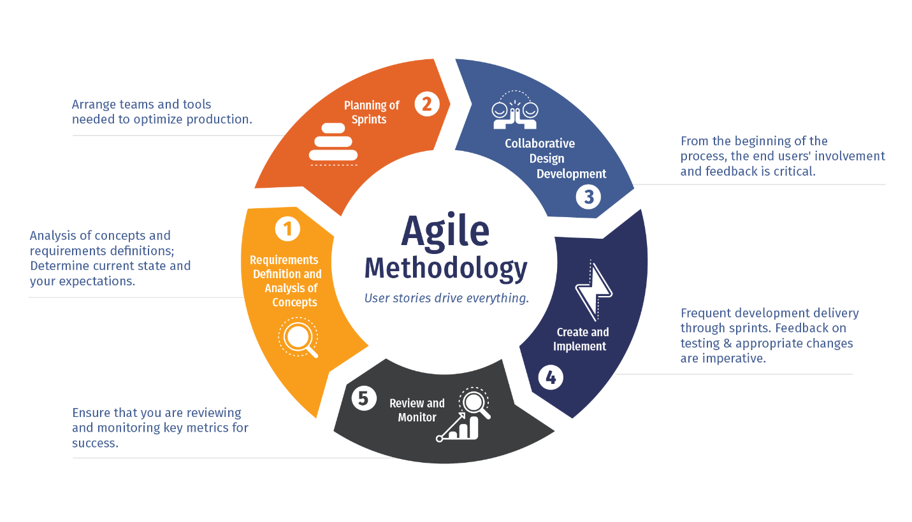

Figure 5 Methodology

# **11.0 Project milestones and deliverables:**

This project is expected to start from March 2022 and end till January 2023 as given in Table 3.

Table 3 Project Timeline

|  |  |  |  |  |  |  |  |  |  |  |  |
| --- | --- | --- | --- | --- | --- | --- | --- | --- | --- | --- | --- |
| **Activity** | **2022** | | | | | | | | | | **2023** |
| **Mar** | **April** | **May** | **June** | **July** | **August** | **Sep** | **Oct** | **Nov** | **Dec** | **Jan** |
| **Literature Review (LR)** |  |  |  |  |  |  |  |  |  |  |  |
| **Problem Identification** |  |  |  |  |  |  |  |  |  |  |  |
| **System Requirements Specification** |  |  |  |  |  |  |  |  |  |  |  |
| **System Design Specification** |  |  |  |  |  |  |  |  |  |  |  |
| **System Development** |  |  |  |  |  |  |  |  |  |  |  |
| **System Testing** |  |  |  |  |  |  |  |  |  |  |  |

# **12.0 System Development with Agile Methodology:**

|  |  |  |  |  |  |  |
| --- | --- | --- | --- | --- | --- | --- |
| **System Development phases** | **Sep** | | **Oct** | | **Nov** | |
| **1-15** | **16-30** | **1-15** | **16-30** | **1-15** | **16-30** |
| **Data Recording** |  |  |  |  |  |  |
| **Pre-Processing** |  |  |  |  |  |  |
| **Model creation** |  |  |  |  |  |  |
| **Model Validation** |  |  |  |  |  |  |
| **Model Deployment** |  |  |  |  |  |  |
| **Command transfer** |  |  |  |  |  |  |

# **13.0 Conclusion:**

The Brain Computer Interfaces (BCIs) are extensively researched as an emerging area. It is aimed to design and develop a BCI that could be attributed with a set of navigational cues to control drones in three-dimensional (3D) physical space. The ultimate goal of this project was to design and develop a fully autonomous, user friendly BCI system that would help the people in the drone control in a three-dimension (3D) space via the power of their thoughts. Our technology intends to improve people’s quality of life by allowing them to interact with the environment.

# **References:**

1. Wolpaw, J.R., et al., *Brain–computer interfaces for communication and control.* Clinical neurophysiology, 2002. **113**(6): p. 767-791.

2. Iuliana MARIN, M.J.H.A.B., Nicolae GOGA, *Drone Control based on Mental Commands and Facial Expressions.* 2020.

3. Catalin Dumitrescu, I.-M.C., Augustin Semenescu, *Using Brain-Computer Interface to Control a Virtual Drone Using Non-Invasive Motor Imagery and Machine Learning.* applied sciences, 2021.

4. Millett, D., *Hans Berger: From psychic energy to the EEG.* Perspectives in biology and medicine, 2001. **44**(4): p. 522-542.

5. Abdelhadi Hireche, Y.Z., Redouane Ayad, *A Decoding algorithm for Non-invasive SSVEP-based Drone Flight Control.* IEEE, 2021.

6. *Efficient Quadcopter Flight Control Using Hybrid SSVEP + P300 Visual Brain Computer Interface.* 2022.

7. Placidi, G., et al., *Basis for the implementation of an EEG-based single-trial binary brain computer interface through the disgust produced by remembering unpleasant odors.* Neurocomputing, 2015. **160**: p. 308-318.

8. Lin, J.-S. and Z.-Y. Jiang, *Implementing Remote Presence Using Quadcopter Control by a Non-Invasive BCI Device.* Computer Science and Information Technology, 2015. **3**(4): p. 122-126.

9. Chiuzbaian, A., J. Jakobsen, and S. Puthusserypady, *Mind Controlled Drone: An Innovative Multiclass SSVEP based Brain Computer Interface.* 2019: p. 1-5.

10. Vishwanath, R.M., S. Kumaar, and S.N. Omkar, *A Real-time Control Approach for Unmanned Aerial Vehicles using Brain-computer Interface*.* 2018.

11. ∗, I.D.V., J.R.C. ∗, and C.A.P.C. *, *Recognition and Characteristics EEG Signals for Flight Control of a Drone.* 2021.

12. Alshbatat, A.I.N., L. Dong, and P.J. Vial, *AirServer: a Mind-Controlled Assistive Quadrotor Drone Aided by an Intelligent Fuzzy PD Controller.* 2016.

13. Rosca, S., et al., *Quadcopter control using a BCI.* IOP Conference Series: Materials Science and Engineering, 2018. **294**: p. 012048.